Alaska Indoor Growing Curriculum

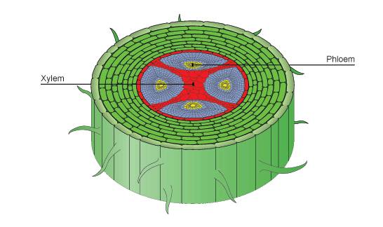
Plant Parts: Stems
Author/Source: Patrick Ryan, Alaska Botanical Garden and Melissa Sikes, Fairbanks Soil and Water Conservation District

Suggested Grade Levels: 2-6th grade

Time: 45 minutes per lesson/2 days

Teaching Goal: Students will review what plants need to grow and learn about the function of stems. They will discuss various stems they eat and learn about the different parts of a stem.

Learning Objectives:
To explore the plant life cycle by focusing on stems and their function for the plant.

Core Ideas:
- Plant Anatomy
- Plant Life Cycles
- Plant Dynamics (circulation and nutrient uptake)
- Evapotranspiration and Transpiration
- Recording Scientific Data in Tables
- Standardized Science Measurements
- Drawing Conclusions from Experimentation (hands-on, observation, drawing, and note-taking)

Alaska State Science Standards: 2-LS4-1, 3-LS4-4, 4-LS1-1, 5-LS1-1, 5-LS2-1, MS-LS1-1, MS-LS1-2, MS-LS1-4

NGSS Standards: 2-LS2-1, 2-PS1-1, 3-LS1-1, 4-LS1-1, 5-LS1-1, MS-LS1-1, MS-LS1-2

Vocabulary:
- Chlorophyll: A green pigment that captures light energy for photosynthesis.

- Circumference: The size of something as given by the distance around it. Ex: the length of the closed curve of a circle.

- Diameter: A straight line going through the center of a circle connecting two points on the circumference.

- Evapotranspiration: Process by which water that has been carried through the plant from its roots to its leaves evaporates from the leaves.

- Flowers: The reproductive part of plants. They often have showy petals and fragrances to attract pollinators such as birds, bees, and other insects. Most flowers have four main parts: petals, stamen (anther and filament), pistil (stigma, style and ovary), and sepals. After flowers are pollinated and fertilized, they produce seeds in the ovary of the flower.

- Fruits: The fleshy substances that usually surround seeds. They protect the seeds and attract animals to eat them. This helps in seed dispersal.

- Leaves: The parts of the plant where photosynthesis usually occurs—where food for the plant is made. The green substance, chlorophyll, captures light energy and uses it to convert water and carbon dioxide into plant food and oxygen.

- Node: The part of the stem that will hold one or more leaves, as well as buds which can grow into branches (with leaves, conifer cones, or inflorescences (flowers)

- Phloem: Transports food from the leaves to the rest of the plant.

- Roots: Anchor the plants in the soil and absorb nutrients and water that are needed by the rest of the plant.

- Seeds: Contain plant material that can develop into another plant. This plant material is called an embryo. Seeds are covered with a protective seed coat and have one or two cotyledons. Cotyledons are the food for the baby plant until it can make its own food from light and are often the first embryonic leaves of the plant.

- Stems: Support the upper part of the plant and act as a transport system for nutrients, water, sugar, and starches. Photosynthesis can occur in the stem of some plants such as: cacti, celery, asparagus, and bananas.

- Transpiration: Transpiration is the process by which water evaporates from the leaves, which results in more water being drawn up from the roots.

- Vascular Bundles: A strand of conducting vessels in the stem or leaves of a plant, typically with phloem on the outside and xylem on the inside.

- Xylem: Transports water and solutes from the roots to the leaves.

Background for Teachers: A stem is one of two main structural axes of a vascular plant, the other being the root. The stem is normally divided into nodes and internodes. The nodes hold one or more leaves, as well as buds which can grow into branches (with leaves, conifer cones, or inflorescences (flowers)). Adventitious roots may also be produced from the nodes. The internodes distance one node from another.

Stems have four main functions which are:
- Support for and the elevation of leaves, flowers and fruits. The stems keep the leaves in the light and provide a place for the plant to keep its flowers and fruits.
- Transport of fluids between the roots and the shoots in the xylem and phloem
- Storage of nutrients
- Production of new living tissue. The normal lifespan of plant cells is one to three years. Stems have cells called meristems that annually generate new living tissue.

Stems usually consist of three tissues, dermal tissue, ground tissue and vascular tissue. The dermal tissue covers the outer surface of the stem and usually functions to waterproof, protect and control gas exchange. The ground tissue fills in around the vascular tissue. It sometimes functions in photosynthesis. Vascular tissue provides long distance transport and structural support. Most or all ground tissue may be lost in woody stems. The arrangement of the vascular tissues varies widely among plant species.

Procedure
Introduction
Teach or review “What is the LAW for plants?” L.A.W. (light, air, water- best for younger students) and/or PL.A.N.T.S. (place, light, air, nutrients, thirsty, soil-best for older students).

Initial Brainstorm/Learning (15 minutes)
- Discuss how just as people have different jobs in our community, different parts of plants have jobs to help the plant grow. Review the 6 plant parts (Roots, Stems, Leaves, Flowers, Fruits, and Seeds).
- Stems have several jobs to do for the plant. Have students generate a list of the possible jobs the stem does and the function of the stem. Answers may vary including supporting the leaves, transporting water/food up and down the plant, etc. Accept all reasonable answers and write them on the white board.
- Discuss stems we eat (celery, rhubarb, asparagus, etc.). Show using a straw how the a stem moves water up to parts of the plant. Discuss how the plant does this.
In the stomata, or the pores in the leaves that allow the leaves to "breathe," wind helps to pull the water out of the pores. Because of the decrease in pressure cause by the liquid being sucked out of the pore, water gets passively pulled up by the roots into the tubes in the tree (xylem) like water moving up a straw. The water molecules in the xylem are under tension and are pulled up the plant stem (or tree trunk. The fancy name for this is the cohesion-tension theory.
- Upper Grades: Look at the stem diagram and talk about the vascular bundles and xylem versus the phloem. Vascular bundles essentially are the network of connections. In humans, that involves arteries, veins and capillaries. In plants, it’s the xylem and phloem. Xylem moves water and minerals up from the roots. Phloem moves sugar (food from photosynthesis), down from the leaves to the rest of the plant. Compare plant stems to trees. Same function.

Hands-On Learning Part 1 (15 minutes)
- Split into groups of 2-3 students/group.
- Pass out tree cookies, 1 per every 2-3 students.
- Look for the rings. Each ring is the xylem tissue for one year of growth. Ask the students to guess how old the tree is by counting the rings.
- Ask students questions about the cookies such as: Are the rings even or symmetrical? Why might they be uneven?
- Have some slices of celery ready and have them compare the celery stem to the tree cookie. What are some of the similarities/differences they can see?

Hands on Learning Part 2 (15 minutes)
- Show students the jar and various items you will use for your experiment.
- Pass out jars to each group.
- Add water and several drops of food coloring to each jar. Add a flower, a stem of celery, a straw, a strip of cut paper towel, and a wooden dowel to each jar.
- Have students fill out the Stem Investigation Sheet. Ask students to predict what will happen with each “stem”, have them predict how the colored water will affect the objects overnight.
- Let the objects sit in the water overnight.

Hands on Learning Part 3 (Next Day)
- Ask the students to observe the changes. Students will note on the worksheet whether the colored water traveled through or up the objects. How far did it travel? Have them measure if it wasn’t all the way.
- Have them make a bar graph on how much water traveled up on each of the objects.
- Ask them why they think the water traveled up the wooden dowel?
- How does the water you drink reach the rest of your body?

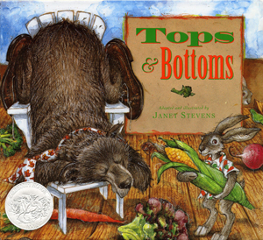
Extensions:
- Read part of Tops and Bottoms by Janet Stevens

- Listen to or sing Banana Slug String Band song “Roots, Stems, Leaves. Flowers, Fruits and Seeds.”
Lyrics to “Roots, Stems, Leaves. Flowers, Fruits and
Seeds.”
Chorus:
Roots, stems, leaves, flowers,
Fruits and seeds
Roots, stems, leaves, flowers,
Fruits and seeds
Roots, stems, leaves, flowers,
Fruits and seeds
Roots, stems, leaves, flowers,
Fruits and seeds
That’s six parts, six parts, six plant parts
that plants and people need.
The roots hold the plant
in the ground.
They gather up the water
that falls around.
And there’s a root inside of me,
because a carrot is a root that I eat.
That’s six parts, six parts, six plant parts
that plants and people need.
A stem is an elevator growing up from
the ground.
The water goes up and the
sugar back down.
And there’s a stem inside of me
because celery is a stem that I eat.
The leaves are the kitchens
where the food is done.
They breath the air and
catch rays form the sun.
And there’s a leaf inside of me
because lettuce is a leaf that I eat.
Chorus…
The flowers are dressed so colorfully.
They hold the pollen and
attract the bees.
And there’s a flower inside of me
because cauliflower is a flower I eat.
The fruit gets ripe, then falls on down.
It holds the seeds and feeds the ground.
And there’s a fruit inside of me
because an apple is a fruit that I eat.
Chorus…
Now you know what this
whole world needs.
It’s roots, stems, leaves, flowers,
fruits and seeds.
There’s six plant parts inside of me
because a garden salad is what I eat.
Chorus…

Assessment:
Assess student worksheets for accuracy, completion, and participation in the activities.

References:
Books:
The Budding Botanist (AIMS Activities Grades 3-6) Investigations with Plants
by Evalyn Hoover, Howard Larimer, Sheryl Mercier, Michael Walsh, Dave Youngs and Beverly Tillman 2009 ISBN: 1-881431-40-1

Plant Plumbing: A Book About Roots and Stems (Growing Things)
by Susan Blackaby 2003 ISBN: 1-4048-0109-X; ISBN: 978-1-4048-0385-5

Tops & Bottoms
by Janet Stevens ISBN: 0-15-292851-0

Websites:
http://mandevillehigh.stpsb.org/teachersites/laura_decker/ap_roots_stems_and_leaves_diagrams.htm

http://www.bbc.co.uk/schools/gcsebitesize/science/add_ocr_gateway/green_world/planttransportrev1.shtml
http://water.usgs.gov/edu/watercycletranspiration.html
https://basicbiology.net/plants/physiology/xylem-phloem/
Stem Layers
https://basicbiology.net/plants/physiology/xylem-phloem/

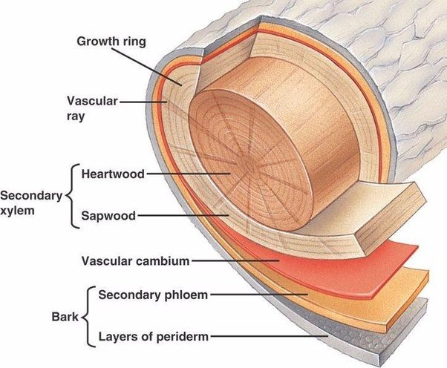
Tree Layers

Stem Investigation

Name___________________________________________ Date____________

Prediction
Predict what will happen to each different type of stem that you have placed in the food coloring water.

1 | Flower | Celery | Straw | Wooden Dowel | Carrot | Paper Towel

Results:
On the next day, record your observations about what happened to each stem.
2 | Flower | Celery | Straw | Wooden Dowel | Carrot | Paper Towel

Conclusions:

